Crowds:
- With good weather, some sites continue to experience heavy day use visitation and trail use on weekends. Sites that had to temporarily close day use entry due to capacity on Saturday and Sunday included: Cloudland Canyon, High Falls, Florence Marina, Providence Canyon, Red Top Mountain, Sweetwater Creek, and Tallulah Gorge. Black Rock reached day use capacity and had a temporary closure on Sunday.

- Franklin Delano Roosevelt experienced heavy day use traffic over the weekend. Fort Yargo, James Floyd, Mistletoe, Watson Mill, and Panola Mountain State Parks reported busier than normal day-use visitation.

- Golf Course activity
  - All courses were very busy and experienced strong visitation, 13% over last year.

- Boat ramp activity
  - Most sites reported the activity levels were busy at the boat ramps, but much less compared to previous weekends.
  - Florence Marina State Parks experienced high usage and had to be closed periodically on Saturday and Sunday.
  - The boat ramp at Fort McAllister exceeded capacity on Saturday with boat trailer parking spilling over into day use parking.
  - Rocky Mtn PFA had a temporary boat ramp closures on Sunday.

- Other crowd related reports include:
  - James H. Floyd experienced heavy day use visitation and trail use on the Marble Mine Trail on Sunday. A modified operational plan is being developed to address these issues.
  - 30+ people on the Fort McAllister fishing pier at one time.
  - Wormsloe began restricting access on Saturday at 1PM letting one car in as one car left.
  - Magnolia Springs had to ask one group under a picnic shelter to use two shelters due to the number of users and requested local law enforcement for an after-hours alcohol issue in the day use area.
  - Hard Labor Creek and AH Stephens State Parks experienced heavy visitation and usage with their equestrian trails.
  - Red Top Mountain State Park staff reported they had to speak to a couple of groups over 10.
  - Sweetwater Creek State Park staff had to speak to a group of 12 and a group of 17 regarding social distancing guidelines over the weekend.
  - Laura Walker had several instances of large groups which had to be addressed.

Staffing issues:
- As of today, the Division as a whole has 118 part-time and full-time staff out due to COVID-19 related reasons. A total of 40 Camp Host Units (approximately 80 people) have left due to COVID-19 and 31 units have been replaced.

- Crooked River Assistant Manager assisted at George L. Smith due to staffing challenges. The Manager at Dahlonega Gold Museum assisted Tallulah Gorge Sunday due to high visitation.
- 13 Staff have tested for COVID-19: 2 positive, 2 still awaiting results, and 9 negative.

Positives
- Modified Operation Plans are effectively working at most sites, with continued adjustments as needed for improvement.
- Strong camping revenue with increasing cottage occupancy.
- Sites are seeing more first-time visitors, many thanking staff for still being open.
- Most sites report good visibility and support by Game Wardens.
- Fort Yargo staff worked with DNR LED and local emergency services personnel on a 13-year-old girl mentally disable female search inside the park. During the afternoon, DNR LED notified the park staff that the girl was found safe and in good health outside the park by local emergency services.
- Staff at Sweetwater Creek and AH Stephens State Parks received guest compliments about the cleanliness and diligence of the staff keeping the bathroom facilities clean.
- Red Top Mountain staff assisted a hiker who had low blood sugar off the trails.
- This week the eRanger Park website page received 814 views and eRanger video series was viewed 278 times on YouTube and viewed 137500 times on Facebook. Total views on Facebook 614200. Total views on Youtube 983
- Website statistics for April 20 – April 26
  - Total Pageviews up 92%- over 1.5 mil this week
  - Reservations page views up 70%
  - Alerts Page received 39,000 views

Challenges
- Staffing shortages and holiday level visitation this early in the year is challenging for staff.
- Closing for the two-hour window at Providence Canyon created a social distancing problem at the restrooms when reopening for the next wave of visitors. They were non-compliant when asked to observe social distancing.
- Many local residents around Wormsloe are entering the site without stopping at the collection box. This could be an issue when normal operations resume. Non-payment at the collection box continues at Fort King George as well.
- On Saturday night, the Sweetwater Creek staff had to call the local Sheriff’s Department for an unruly group of 17 at the bait shop where alcohol was involved. The Sheriff’s Department was not able to make contact with this group. DNR LED was notified about this incident on Sunday morning.
- On Saturday, at Sweetwater approximately 7:30 PM, there were three vehicles involved in an accident on Mount Vernon Road, outside the main entrance gate area. Douglas County assisted with this accident and reported no injuries. On Sunday at Sweetwater Creek, DNR LED was notified about a guest who threatened a staff member due to the park being temporarily closed at the day-use areas.
- On Saturday, Highland Walk at Victoria Bryant State Park had to turn away some walk-ins due to a booked tee-sheet at the time and management of the cart cleaning. These guests were encouraged to use the putting greens and driving range until the tee-sheet lightened up.

Financial Update
Weekend Occupancy:
Past Weekend:
Overall, we saw a 4% drop in occupancy for all reservables, this is the same as the previous weekend. Cottage rentals are starting to return. Last weekend we were at 49% occupancy, this past weekend we had 63% of our cottages occupied. Camping had a 5% increase up to 87%! And almost all of yurts were occupied, but we did see a drop from 97% to 95%.

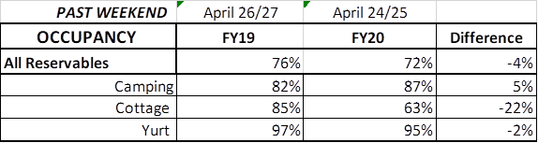

Upcoming Weekend:
If we look at the upcoming weekend, we are currently only at a 1% decrease for all reservables. (Last week we were seeing a 15% decrease at this point and the week before that a 17% decrease) Camping is already showing a 10% increase over last year! Although, it was wet in Northwest and Coastal GA this weekend last year. Cottages are showing a 42% decrease. Last weekend at this point we were showing a 49% decrease and ended the weekend at only a 22% reduction in occupancy. For this upcoming weekend, yurts are 100% booked. This is up 9% over last year.

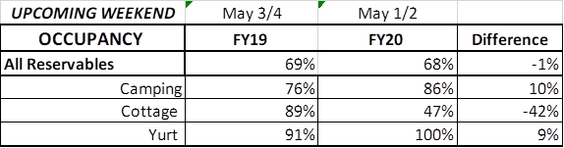

Revenue:
For the month of March through April 26th, we have seen a decrease in revenue of 29% or a loss of $1.9 Million. This past week, April 20th – 26th, we actually saw a 22% or $184,000 increase in overall revenue. This is the second week our revenue has increased since the COVID situation began. Last week we saw a 3% increase.
ParkPass has decreased 14% or $102,000 during this timeframe. This past week, Parkpass dropped 28% compared to the same weekend last year. Customers are continuing to utilize the online daily parkpasses, selling 1,586 or $7,930 worth of passes this past weekend.
Golf continues to see a substantial improvement over last year, having a 13% increase this past week. During this entire time period, golf’s revenue has increased 4% or $14,000.
For overnight accommodations – camping revenue has now increased 17% or $354,000. This past weekend it increased 154% or $363,000. This is the 2nd week in a row the revenue has more than doubled. Cottages are now at a 48% loss for March/April, it was at a 58% decrease last week; yurts are at a 29% loss, 3rd straight week that yurts have increased revenue, jumping up 26% this past week.
We are seeing the revenue significantly improve over last week due to several reasons:
- In early April we changed policy from collecting only a one-night deposit when booking a reservation, to collecting all revenue at the time of booking. This is the reason for the significant increase to camping, and slowing the bleeding resulting from lower cottage occupancy. This will have an effect on future revenue collections.
- Camping occupancy has actually improved over the previous year for the 2nd weekend in a row.
- And again, the number of cancellations is starting to significantly slow down. Although we do need to keep in mind, that for future refunds, we will be refunding the revenue for the entire stay, rather than just a one-night deposit.

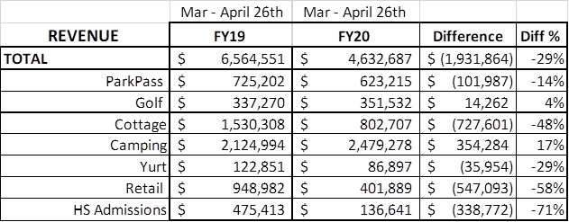

Cancellations/Refunds:
Through this morning, we have had 21,700 cancellations, including $1.9 Million in actual refunds and a loss of future revenue of $7,100,000.
This is 1,700 more than last Monday, when we were at 20,000 cancellations. The significant drop in the number of cancellations continues, as initially we had 4,000 – 5,000 a week and now we are down to 1,700 this past week. Last year during the same week we had 500 cancellations, so customers are still continuing to cancel reservations at a higher rate than previous years.
Last year during March/April YTD, we had 5,500 cancellations, including $280,000 in actual refunds and a loss of future revenue of $1.3 Million.
So, total cancellations have increased over 16,200 or 395% and the amount of refunds have increased $1.6 Million.

